*Analyzes the business partner strategy with qualitative analysis as well as a Qlik interactive dashboard of CEO data*

**Assignment**

**3**

A3

ALY6060 Decision Support & Business Intelligence

Assignment 3 – Working With Business Partners

**PREPERATION:**

By: John DiSessa

For: Professor Ellis

On: June 12th, 2022

Introduction

Business partners and CEOs are the most influential parts of any business. In Part One of this assignment, we define what business partners are, explain why they fail, and how to overcome those challenges. In Part Two, we analyzed the top 243 CEOs using an interactive Qlik dashboard to see if inequitable companies put themselves at a disadvantage. For the amount of knowledge and expertise companies have at their disposal, a shocking amount of them operate sub optimally or even hinder their own progress. The analysis in this report provides strategies to avoid common downfalls and give leadership the tools to succeed in any industry.

Part One

**Business Partner Definition**

While there are varying definitions of what a business partner is, we consider business partners to be individuals or organizations who have influence over a leadership group’s decision making. We wanted to keep our definition broad because from our research, every industry has various types of business partners. They can vary in size, impact, monetary considerations, expectations, etc. Our course module has a more specific definition of the business partner concept: “A business partner is a leader who is included in conversations about the future, mission, goals, and overall strategy of a company or organization. A business partner, while not a member of the C-suite or executive leadership team, has a voice in high level conversations that overlap with their areas of expertise. The business partner is generally considered to be a strategic partner that can offer recommendations, make decisions, and carry out goals. To be valued as a business partner and merit an invitation to conversations about the organization’s future, a business partner must have a certain set of skills and knowledge.” While we agree with most of this definition, it fails to truly distinguish between good and bad business partners. We agree that a business partner should be someone from outside the executive leadership team so that they can provide unbiased and objective reasoning. We also agree that a business partner should be considered a strategic partner. Both of these aspects are exactly why data-driven people make the best business partners. However, we think that business partners need to be complimentary to leadership instead of supplementary and not “overlap with their areas of expertise”.

**Why Business Partners Fail**

In the first section we mentioned the threat of business partners not complimenting the skills of company leadership. If leadership gets business partners with similar skills and mindsets, leadership can make decisions based on confirmation bias, groupthink, and evaluating decisions in an echo chamber of self-reinforcing ideas. This can lead to over-confidence, a lack of creativity, and a failure to find optimal solutions if they require a change in the status-quo. “Confirmation bias happens when a person gives more weight to evidence that confirms their beliefs and undervalues evidence that could disprove it.” When looking for business partners, company leadership is more likely to select business partners that agree with them rather than challenge their existing beliefs. Even when presented with accurate data, if the conclusions don’t match leadership’s existing ideas, they won’t be taken seriously. With groupthink, the leadership team and business partners tend to agree for the sake and easiness of the group morale rather than present individual conflicting opinions. “… the desire for group cohesion effectively drives out good decision-making and problem solving.” Both of these phenomena result in sub-optimal decision making. In many instances, they even are a waste of time and money. Business partners who simply agree don’t provide any value despite being compensated for doing so.

Business partners can also fail if their incentives don’t align with the company leadership. It is crucial that business partners and company leadership align their financial and strategic incentives so that they all benefit from working towards a mutually beneficial common goal. An alignment of incentives can create a positive culture, improve self-governance, and optimize talents and skills. “Incentives drive behavior, and behavior spawns culture.” If everyone is motivated by a common goal, employees are likely to give a little more effort than if they were just forced to work. All those little improvements add up over time. Self-governance creates less clutter and ambiguity in the workplace. People can feel confident in their decisions, don’t second guess themselves, and can work efficiently without always being told what to do or being micro-managed. Lastly, if roles are defined and it is clear what their current strengths and weaknesses are, companies can effectively hire areas with a talent gap and position employees in roles that can help them achieve their personal goals.

**Overcome Business Partner Challenges**

In order to overcome the challenges listed above, organizations can use data-driven decision making and root-cause analysis. Data-driven decision making allows companies to become more agile, adaptive, and operate more efficiently. If a company has been operating a certain way for a number of years, some business partners may only suggest moderate changes that are insufficient to keep up with competitors. With the data to back up partners’ decisions about making more radical changes if needed, leadership can actually use the advice of business partners to potentially save their business. Data can also show areas of company inefficiency. Leadership may be unaware of every single aspect of their business but data can quantify all of their operations. This can allow companies to make changes to their corporate structure in order to reduce waste. Root-cause analysis is a simple yet effective method for identifying the proper business partners. If done properly, leadership would know exactly what their deficiencies are and be able to find business partners that can complement their weak links.

Part Two

Using Qlik, we developed an interactive dashboard that shows the pay inequity between CEOs and their employees. Our dataset from Kaggle collected data on the top 243 CEOs based on their 2020 pay (originally sourced from the New York Times). We used interactive bar charts to compare CEO salaries, average employee salaries, company revenue, and CEO to employee pay ratios. Our goal was to determine which companies had overpaid or underpaid CEOs and employees.

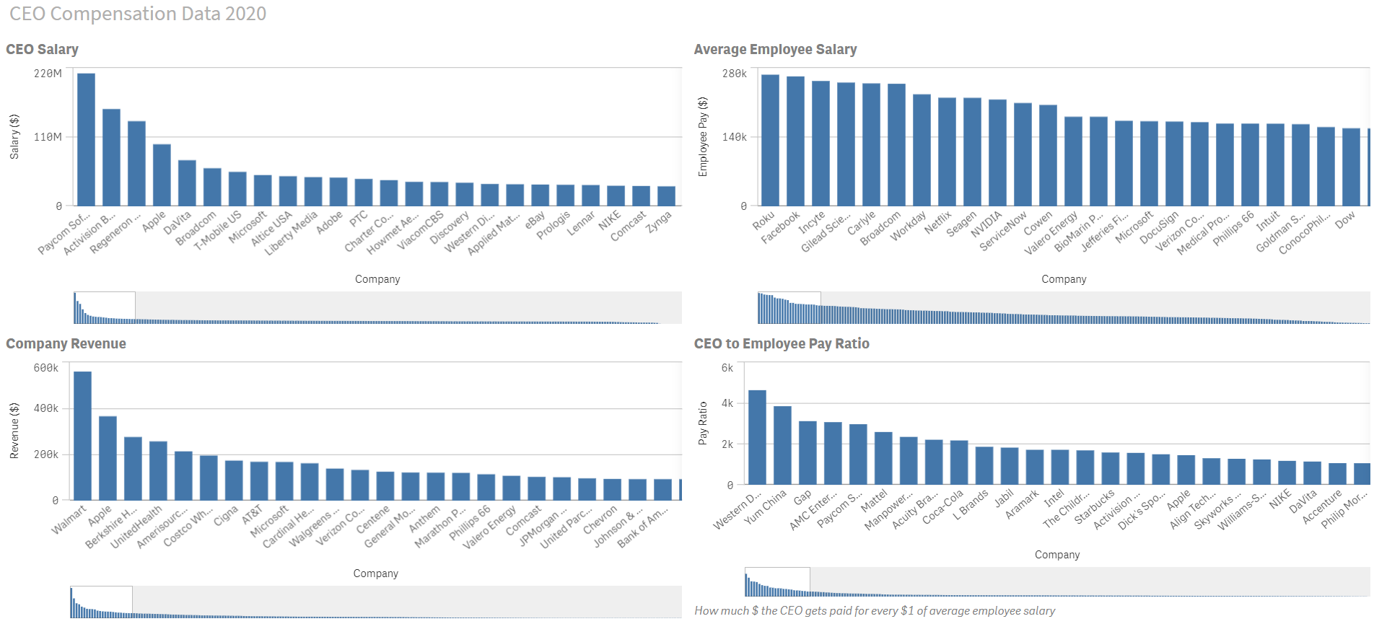

The most inequitable company based on our data was Paycom Software. Their founder and CEO, Chad Richison, earned $211 million in total compensation despite his company only earning $841 million in revenue. Out of all 243 companies, Paycom compensated its CEO the most (with the next highest paid CEO earning 27% less than Chad) despite the company earning the lowest revenue in our whole dataset. Their average employee earned $71,000 per year which is good for about the 50th percentile, however that is still an egregious 2963:1 pay ratio. For every $1 earned by the average employee, Chad earned $2,963. That ratio was good for 5th highest in our dataset. Western Digital had the highest pay ratio with their CEO, David Goeckeler, earning $4,628 for every $1 earned by his employees. The company did earn over $16 billion in revenue last year but that is still only in the 40th percentile in our dataset. David made almost $36 million in 2020 compensation which put him in the 91st percentile. As if you needed more proof of this disgusting pay gap, his employees earned an average of $7,719 per year. The last company we analyzed was Walmart who earned $559 billion in 2020 revenue, which was almost 35% more than the second largest company in Apple. Their CEO Doug McMillon earned $21 million which only put him in the 61st percentile. However, their employees are still grossly underpaid as the average employee only earned $20,942 (8th percentile). The examples above were only the most noteworthy, but you can visit our public dashboard [here](https://10w4cqms9yx22vh.us.qlikcloud.com/sense/app/2dc2d193-30e3-4b69-aee0-905b62774618/sheet/46ee31ea-52dc-462a-920d-5585e9e6d5f9/state/analysis) and find the data for your favorite company.

Summary

In Part One we were able to define a business partner, identify common traps that cause the business partner strategy to fail, and provide strategies to fix those problems. It is clear from Part Two’s analysis that many companies do not use data-driven decision making or root-cause analysis to effectively manage their business partners. Many company CEOs are grossly overpaid, their employees are underpaid, and their revenues suffer because of it.

Citations

Deshler, Reed, and Author Reed Deshler. “10 Benefits of an Aligned Organization.” *AlignOrg Solutions*, 15 Dec. 2020, https://alignorg.com/10-benefits-of-an-aligned-organization/.

“Echo Chambers and Why They Are so Dangerous.” *Paleo Foundation*, 30 Oct. 2019, https://paleofoundation.com/why-echo-chambers-are-so-dangerous/#:~:text=This%20closed%20loop%20system%20of,and%20unfortunate%20examples%20of%20extremism.

Grensing-Pophal, Lin. “The Problem When Incentives Aren't Aligned.” *HR Daily Advisor*, 14 Jan. 2019, https://hrdailyadvisor.blr.com/2019/01/14/the-problem-when-incentives-arent-aligned/.

“Groupthink.” *Corporate Finance Institute*, 10 Feb. 2022, https://corporatefinanceinstitute.com/resources/careers/soft-skills/groupthink-decisions/.

Jo, Alan. “Highest Paid CEOS - Total Compensation.” *Kaggle*, 15 May 2022, https://www.kaggle.com/datasets/alanjo/highest-paid-ceos-total-compensation?resource=download.

Management, Michael. “A Look at SAP Business Partner.” *SAP Training and SAP Access by Michael Management*, https://www.michaelmanagement.com/blog/sap/an-introduction-to-sap-business-partner.

the Mind Tools Content Team By the Mind Tools Content Team, et al. “Avoiding Groupthink: Avoiding Sometimes-Fatal Flaws in Group Decision Making.” *Groupthink - Decision Making Skills Training from MindTools.com*, https://www.mindtools.com/pages/article/newLDR_82.htm#:~:text=Groupthink%20is%20a%20phenomenon%20that,decision%2Dmaking%20and%20problem%20solving.

Noor, Iqra. “How Confirmation Bias Works.” *Examples and Observations of a Confirmation Bias | Simply Psychology*, 10 June 2020, https://www.simplypsychology.org/confirmation-bias.html.

Pike, Gareth. “6 Benefits of Data Driven Decision Making.” *Make a Success of Business Technology and Futureproof Your Business with Insights from BTR*, https://insights.btrhub.com/data-driven-decision-making.

Reuter, Dominick. “The CEO of a Company You've Probably Never Heard of Earned $211 Million in Compensation Last Year - and the Title of Highest-Paid Chief Executive, According to a New Ranking.” *Business Insider*, Business Insider, 26 Apr. 2021, https://www.businessinsider.com/2020-highest-paid-ceo-211-million-paycom-chad-richison-2021-4.

“Root Cause Analysis Explained: Definition, Examples, and Methods.” *Tableau*, https://www.tableau.com/learn/articles/root-cause-analysis.

“Why Business Partnerships Fail.” *Capitalist Creations*, 28 June 2014, https://capitalistcreations.com/why-business-partnerships-fail/.